# Lab 16

Instructor: Sidra Khatoon E-mail: skhatoon[@uit.edu](mailto:ad@uit.edu)

# Objective

# The objective of lab is creating a shopping cart app using Provider (Part 1)

# .

**Student Information**

|  |  |
| --- | --- |
| **Student Name** |  |
| **Student ID** |  |
| **Date** |  |

**Assessment**

|  |  |
| --- | --- |
| **Marks Obtained** |  |
| **Remarks** |  |
| **Signature** |  |

# Objective

# The objective of lab is create a shopping cart app using Provider (Part 1)

# Instructions

You have to perform the following tasks yourselves. Raise your hand if you face any difficulty in understanding and solving these tasks. **Plagiarism** is an abhorrent practice and you should not engage in it.

# How to Submit?

Submit lab work using Teams.

# Shopping Cart App using Provider:

The app has two separate screens: a catalog, and a cart (represented by the MyCatalog, and MyCart

widgets, respectively). It could be a shopping app, but you can imagine the same structure in a

simple social networking app (replace catalog for "wall" and cart for "favorites").

The catalog screen includes a custom app bar (MyAppBar) and a scrolling view of many list items (MyListItems).

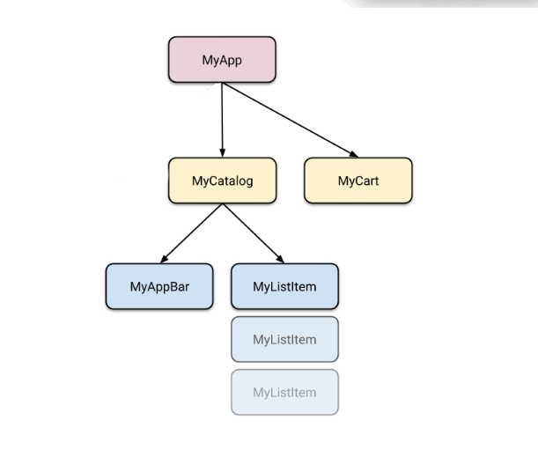

# Implementation:

First, we set up our code for two screen such catalog screen and cart screen. We must set provider class for state management in app. We have to create an item model in which we define how our items are stored. We also must create an item list for all items.

**Now we start creating our UI for Catalog Screen**

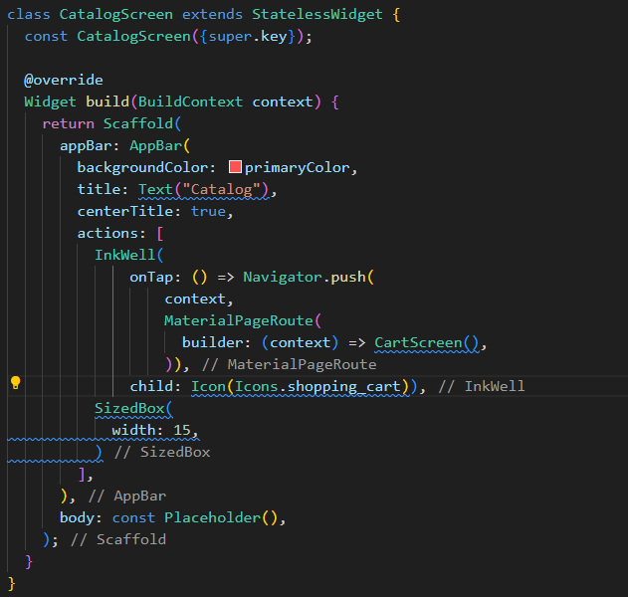

**Now we set the body part of catalog screen with list view builder and list tile.**

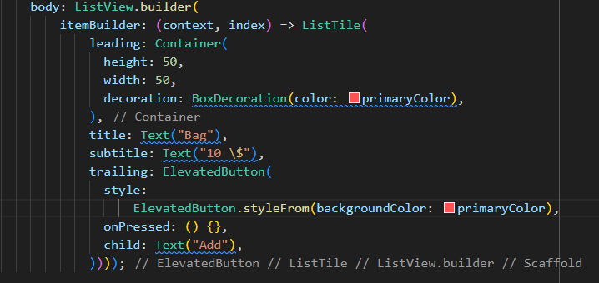

**We extract the list tile code in new file named as item widget. This is our custom widget.**

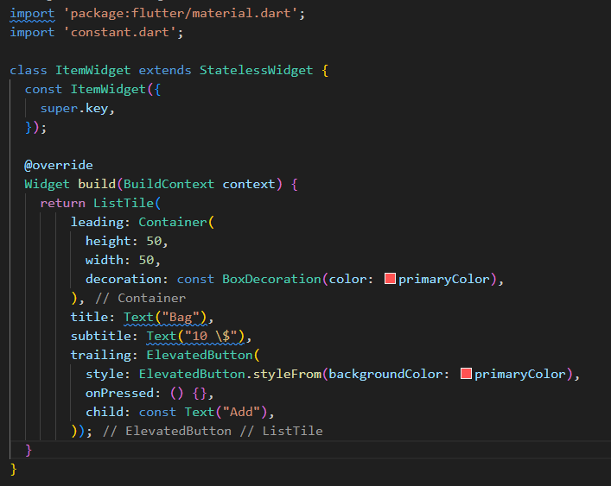

**Assessments:**

**Q1: What is the purpose of the Provider package in Flutter?**

**Q2: What is the difference between ChangeNotifierProvider and Provider in Flutter?**

**Q3: How do you update and listen to changes in state using Provider?**

**Q4: Explain the role of Consumer in the Provider package.**